Website Specifications

Notorious Motors is a premium car dealership specializing in the sale of high-end together with classic vehicles. The dealership offers a curated collection of automobiles ranging from timeless classic cars to modern luxury and performance vehicles. The website will serve as a digital showroom where customers can explore available cars, learn about the dealership, submit enquiries, and request consultations.
Objective & Goals
The website’s objective is to serve as a digital showroom for the notorious dealership. Goals include:
- Displaying f vehicles with detailed specifications and images.
- Providing easy access to dealership information (location, contact, services).
- Supporting lead generation through inquiry forms and booking test drives.
- Building trust and credibility with customers through transparent information.
- Providing the people with a wide variety of cars from classic to present.
- Dealer in quality pre-owned vehicles too.
- Provide car customers with the option to customise their cars new or old
Target Audience
- Demographics: Adults aged 23–60, professionals, families, car enthusiastse and luxury lifestyle buyers even business professionals.
- Technical Aptitude: Moderate to high; familiar with browsing online catalogs, comparing products, and using mobile devices.
- User Needs: Quick access to car listings, financing options, dealership services, and contact details Moderate to high technical ability, since they are expected to use modern browsers, forms, and online catalogues.

Type of Website
A business and product catalog website showcasing vehicles, dealership services, promotions, and customer support.
Content sections for the pages
Home page
- luxury car images in rotation
- Welcome text
- Featured categories:
  - Classic Collection
  - Modern Luxury
  - Performance Cars
- Call to action: “Browse Inventory”
- Short dealership intro
Inventory page
- Grid of cars with image, model, year, price, status
- Filter sections like:
  - Classics
  - SUVs
  - Sedans
  - Sports Cars

Classics page
- Dedicated section for vintage and collector cars
- History-style descriptions
- Showcase rare vehicles
About page
- Company story
- Mission and vision
- Why choose the dealership
- Customer promise
Feedback page
- HTML form with:
  - Full name
  - Email
  - Phone number
  - Preferred car
  - Message

Information Design & Taxonomy
Introduction
Information design and taxonomy focus on how website content is organized, grouped, and accessed by users. For this premium automotive dealership website, the aim is to create a clear structure that allows visitors to move easily between pages, find relevant vehicle categories, and access company and contact information without confusion. The website should follow a logical navigation structure and support quick access to important content within a few clicks, in line with good web design practice and the assignment brief’s requirement for information architecture and a site map.
Information Architecture
The website content will be divided into the following main sections:
Home
This is the landing page and entry point to the website. It introduces the dealership brand, highlights featured vehicle categories, and provides quick navigation to other pages.
Vehicle Collection
This section presents the main range of vehicles available through the dealership. It acts as the primary showroom page and groups vehicles into broad categories.
Classic Models
This page focuses on vintage, collector, and heritage vehicles. It gives users a dedicated area to explore classic automotive options.
Modern Luxury Models
This page presents newer premium vehicles, including executive, luxury, and performance cars.
Services
This page outlines dealership-related services such as vehicle sourcing, customer consultations, showroom appointments, and after-sales support and vehicle customization.
About Us
This section provides background about the business, including its identity, values, and overall purpose.
Contact / Feedback
This page enables visitors to contact the dealership and submit enquiries or feedback using an HTML form.

Taxonomy
The content will be grouped as follows:
1. Corporate Information
- Home
- About Us
- Services
2. Product Information
- Vehicle Collection
- Classic Models
- Modern Luxury Models
3. User Interaction
- Contact / Feedback
This structure ensures that users can clearly distinguish between general business information, vehicle-related content, and communication features.

Navigation Structure
The main navigation menu will appear consistently across all pages and will include:
- Home
- Vehicle Collection
- Classic Models
- Modern Luxury Models
- Services
- About Us
- Contact / Feedback

Site Map
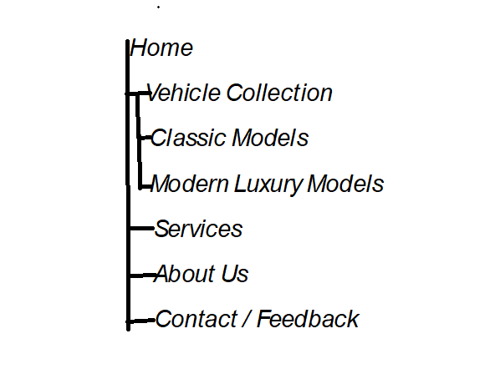

Storyboard / Flowchart of Navigation
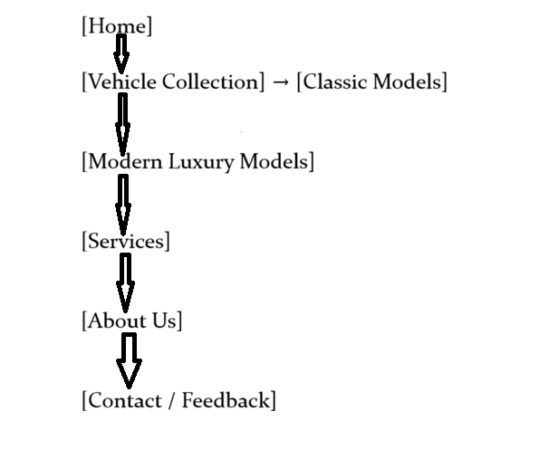

Navigation Paths
The website will be designed so that users can access key content quickly and efficiently. A customer / vistor should be able to:
- move from the home page to any main section directly through the navigation bar
- browse vehicle categories from the collection page
- learn about the company and its services
- complete a contact or feedback form without unnecessary steps

Technical Brief
Development Technologies
HTML5
HTML5 will be used to create the structural layer of the website. It will define the content and layout of each web page, including headings, paragraphs, images, navigation menus, sections, tables, and forms. HTML5 semantic elements such as <header>, <nav>, <main>, <section>, <article>, and <footer> will be used to improve structure and accessibility. The feedback page will also use HTML5 form elements and validation attributes such as required, email, and tel.
CSS3
CSS3 will be used for the presentation layer of the website. It will control colours, fonts, spacing, layout, responsiveness, and the overall visual appearance of the site. CSS3 will help create a premium and consistent design that reflects the luxury automotive theme of the website. External style sheets will be used to keep styling separate from content and to improve maintainability. The design will also support page uniformity across all pages.
JavaScript
JavaScript will be used to add interactivity and dynamic behaviour to the website. It may be used for features such as responsive navigation menus, image sliders, form enhancement, validation support, and interactive user interface elements. This will improve user experience and make the site more engaging.
Bootstrap Framework
Bootstrap may be used to simplify responsive design and help the website display correctly on desktops, tablets, and smartphones. It provides a grid system, ready-made UI components, and utility classes that support modern page layouts and mobile responsiveness. The assignment marking guide specifically rewards good use of Bootstrap in the presentation layer.
Software Tools
Visual Studio Code (VS Code)
VS Code will be the main code editor used to write and manage the HTML, CSS, and JavaScript files. It is suitable for web development because it supports syntax highlighting, extensions, formatting, live preview tools, and project folder management.
Git and GitHub
Git will be used for version control during development, while GitHub will be used to store the project repository online. GitHub Pages will be used to publish the live website, as required by the assignment brief. Git commands such as git init, git add, git commit, git push, and repository publishing tools will be used to track changes and upload the site files.
Web Browsers
Different browsers such as Google Chrome, Mozilla Firefox, Opera, and Microsoft Edge will be used for browser compatibility testing. This is important because the assignment requires the website to display across multiple browsers.
Graphics Editing Software
A graphics editing tool such as GIMP, Canva, or Adobe Express will be used to create or edit visual assets such as logos, banners, icons, and page images. This is important because the assignment encourages the use of original graphics and multimedia content for branding and presentation.
Website Resources
Images
High-quality vehicle images will be used throughout the website to support the premium automotive theme. These images may include classic cars, luxury sedans, sports cars, and showroom photography. Where necessary, optimized image sizes will be used to improve performance.
Branding Materials
The site will include custom branding elements such as a dealership name, logo, colour palette, and slogan. These materials help create a consistent visual identity across the website.
Icons and Visual Elements
Icons may be used for navigation, contact details, services, and social media links. These improve readability and visual appeal.
Text Content
Original written content will be produced for each page, including company information, vehicle descriptions, service descriptions, and customer guidance. This helps reduce plagiarism and ensures the website content fits the chosen business concept.
Hosting and Deployment Tools
The website will be hosted using GitHub Pages, which allows static websites built with HTML, CSS, and JavaScript to be published online. The project files will be stored in a GitHub repository, and the live site will be linked to the repository for public access. This hosting approach is suitable because it is free, reliable for student projects, and aligns with the assignment requirement to publish the website using GitHub Pages.
Why These Tools Were Chosen
The selected tools are appropriate because they match the requirements and complexity of the project. HTML5, CSS3, and JavaScript are the standard technologies for front-end web development. VS Code provides a practical environment for coding and project organization. GitHub and GitHub Pages support version control and web publishing. Bootstrap makes responsive design easier, while graphics software supports the creation of professional visual elements. Together, these tools provide everything needed to plan, build, test, and publish a functional and visually appealing academic website project.

